Introduction

This report presents a case study on the development of the OPAIC Virtual Reality Learning Management System (OPAIC-VR LMS) for Healthcare Training at Otago Polytechnic. The initiative aims to create an immersive VR environment where healthcare and nursing students can practice simulated medical procedures, such as patient diagnosis and emergency response, within a virtual hospital setting. The platform will include multi-user capabilities, enabling students to collaborate in real time, and must integrate smoothly with the Polytechnic’s existing Learning Management System (LMS). Moreover, the project will incorporate culturally responsive healthcare practices, aligned with Iwi/Māori health frameworks and traditions.The project will also require user training for both students and lecturers, ensuring they are confident in using the VR technology. Key deliverables include high-quality VR hardware and software, a user guide, a training program, a culturally inclusive healthcare curriculum embedded in the VR simulations, and a risk management plan addressing potential technology malfunctions and user resistance.

For this project, three project management methodologies have been proposed: Waterfall, Scrum, and Extreme Programming. Among these, Scrum is deemed the most suitable methodology due to its flexibility, iterative approach, and capacity to manage complex and evolving requirements. Additionally, two Māori values, Whanaungatanga and Kaitiakitanga, have been identified to guide the project, ensuring that Māori values and protocols are embedded throughout the process.With the 3 methodologies applicable for OPAIC-VR LMS, I critically analyse the 3 methodologies below.

Project Management Methodologies (VR Learning Platform for Healthcare Training)

2.1 WATERFALL
The Waterfall methodology is one of the earliest project management approaches. It was created by Dr. Winston Royce in 1970 to oversee the development of large-scale software projects (Waseem, 2024). It is a step-by-step, linear approach to project management, where each phase must be finished before proceeding to the next one (Clifford, 2023). The figure below shows the phases of the Waterfall Model and the phases are discussed in detail below.

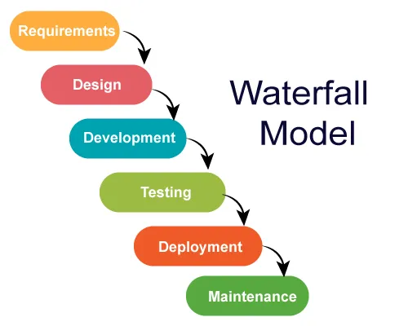

Figure 1: Waterfall Model (Behera, 2023)

2.1.1 REQUIREMENTS PHASE
This is the early planning phase where the team collects all necessary information to set the stage for a successful project (Laoyan, 2024).
In this phase, the application of VR technologies within this field is studied, particularly in the development of VR simulators and training environments. VR simulator development is a suitable and rich domain to study, as the VR technology for production could be used for the development phases (Waseem, 2024).

2.1.2 DESIGN PHASE
The design phase is when the project team determines the hardware to be used and outlines other key details, such as the programming languages, unit testing strategies, and user interface designs (Laoyan, 2024).
This phase starts with defining the user needs, information requirements, and functional specifications. Users actively participated in the design process by providing direct feedback, being observed during interactions, and testing mock-ups and prototypes to ensure the design met their needs (Waseem, 2024).
2.1.3 DEVELOPMENT PHASE
This is the phase where the development process begins in full swing. The team brings the software to life by following the guidelines established in the requirements and system design phases. Using the requirements document from the first step and the system design framework from the second, they ensure the software is built according to plan (Laoyan, 2024).
VR development consists of multiple stages, including designing the virtual environment, developing 3D models, programming interactive features, incorporating audio and visual elements, testing functionality, and optimizing performance for different VR devices (Dobroskokina, 2023).
2.1.4 TESTING PHASE
This phase is dedicated to rigorously testing and assessing the developed software to ensure it aligns with the initial requirements. It is also the stage where bugs and system issues are detected, addressed, and refined to enhance overall performance (Nguyen et al., 2020).
During the VR testing phase, users will go through a tutorial or learning stage to help them get acquainted with the virtual environment. After the familiarization phase, the users will go through test scenarios (Sankaranarayanan et al., 2018).
2.1.5 DEPLOYMENT PHASE
Once testing is complete and the software is fully functional, it’s deployed to the production environment. This is when the software is made available for end users (Jain, 2024).
During the deployment phase, developers gather code that will be deployed, including libraries, configuration files, and resources. Then developers will deploy it on a test server to run a series of tests and fix any bugs that are present. Finally, it is deployed to a live environment and the phase goes to maintenance phase (Confianz, 2023).
2.1.6 MAINTENANCE PHASE
After the software is already released, it may need some modifications, improvements, errors correction, and refinement accordingly. Thus, this phase is the process of taking care of such concerns (Jain, 2024).
During the Maintenance phase, The developers stay attentive and continuously monitor the software, allowing them to promptly address and resolve any bugs detected on the live server (Confianz, 2023). Customer expectations are fulfilled by implementing various enhancements and adjustments to ensure the system functions smoothly and efficiently (Fu et al., 2015; April and Abran, 2012, as cited from Gulec et al., 2017).

2.2 SCRUM
Scrum is an agile approach to software development that focuses on working in small, manageable chunks. It's a way of developing products that’s flexible and collaborative, allowing teams to adapt quickly as they go. Scrum was introduced in 1993 by Jeffrey Sutherland at the Easel Corporation as a framework designed to produce high-quality software efficiently. It emphasizes delivering incremental progress in short, time-boxed iterations called sprints (Sassa et al., 2023). The figure below shows the phases of the Scrum Model and the phases are discussed in detail below.
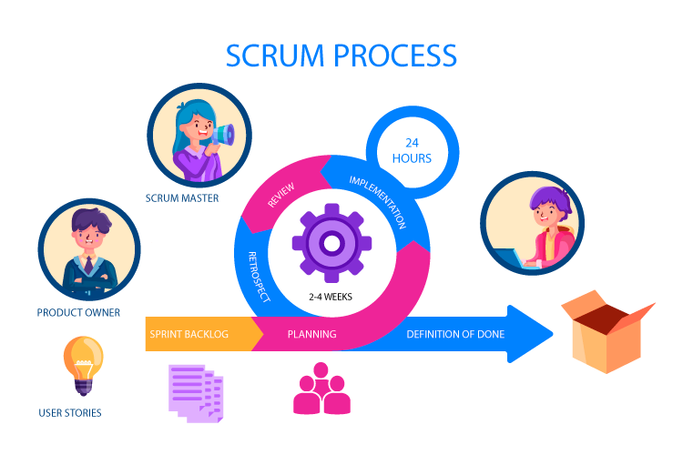
Figure 2: Scrum Process Model (Bhaskar, 2024)
2.2.1 PLANNING PHASE
At the beginning of each Sprint, the Scrum Team conducts a Sprint Planning meeting. This event focuses on setting the Sprint Goal and selecting items from the Product Backlog to work on during the Sprint (Bhaskar, 2024).
During this phase, the user stories or tasks such as VR software, and VR hardware tasks is discussed between the product owner and the developers (E. Lozada-Martinez et al., 2019). After the discussion, the priority and estimation of effort is done for each tasks (Mayor & López-Fernández, 2021).
2.2.2 IMPLEMENTATION PHASE
The implementation phase focuses on carrying out tasks and activities necessary to achieve product goals and complete project deliverables. One key practice during this stage is the daily stand-up meeting—a brief yet essential check-in where the team syncs up on progress, identifies roadblocks, and ensures alignment within the sprint. In these meetings, each team member shares three key updates: what they accomplished the previous day, their planned tasks for the day, and any challenges they are encountering (Stevens, 2022).
During this phase, the developers start to develop VR features in short time due to iterations, which makes it possible to better respond to the needs of the industry/user (E. Lozada-Martinez et al., 2019).

2.2.3 REVIEW PHASE
Before the end of the sprint, the Scrum Team holds a Sprint Review to showcase the work completed during the Sprint (Bhaskar, 2024). The Development Team is present to show their work and receive feedback. The Stakeholders is also present to see the work done (Houwing, 2019).
During this phase, the VR features developed during the sprint are presented by the developers and receive feedback from stakeholders for signoff or possible improvements (Peters, 2024).

2.2.4 RETROSPECTIVE PHASE
The retrospective is the principal means through which a team focuses on continuous process improvement. As such, retrospectives provide Scrum teams a method which will allow them to identify and resolve issues that impact team performance (Marshburn, 2018).
During this phase, the developers, testers, product owner, scrum master identify which part they did well, which part they did not do well, and what actions they can implement on the next sprint to improve their process (Marshburn, 2018).

EXTREME PROGRAMMING (XP)

Extreme Programming (XP) is an another agile methodology that focuses on rapid development, continuous feedback, and high-quality software delivery. XP’s origin dates back to the 90s when Kent Beck – who would later become one of the authors of the Agile Manifesto – created it when hired to lead Chrysler’s Comprehensive Compensation System team (Venema, 2024). XP values communication, simplicity, feedback, courage, and respect, using them as guides for time management and technique. XP employs practices that encourage creativity while acknowledging human fallibility, to produce quality software sustainably. XP teams aim for transparency and accountability, mirroring typical business operations, while also celebrating the human element involved in software creation. This approach allows teams to develop software at a lower cost, with fewer defects, higher productivity, and a greater return on investment. XP assumes team members want to collaborate, improve their skills and relationships, and are willing to adapt to achieve shared goals (Beck, 2000).

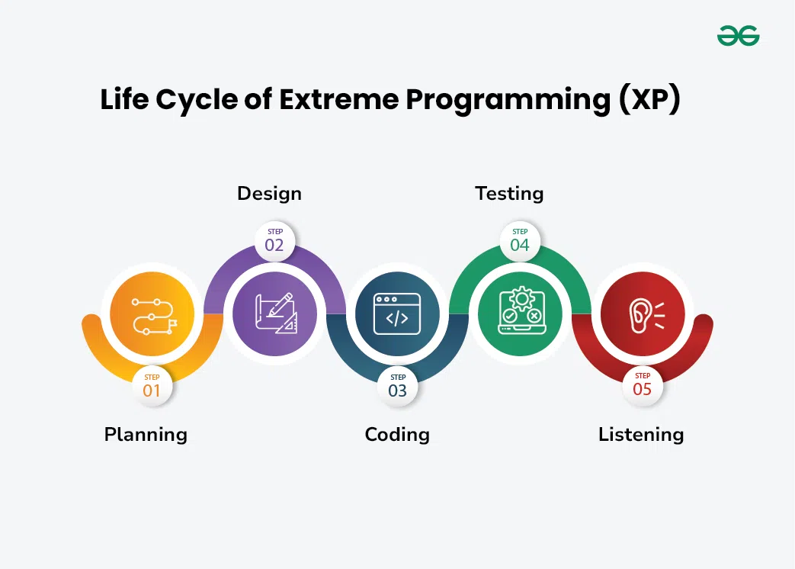
Figure 3: Extreme Programming (XP) Life Cycle (GeeksforGeeks, 2024)

PLANNING PHASE
Planning defines the first phase of the XP lifecycle. In this stage, customers meet the team of developers and outline their requirements through user stories that reveal the desired result. The team then uses these client requirements to create multiple iterations necessary to achieve the desired functionality on a part-by-part basis. In situations where user stories are challenging to estimate and develop iterations, ‘spikes’ are introduced, which signify the necessity for further research (Kanade, 2022).
In this phase, the requirements is set between developers and customer and then the developers break it down into simpler tasks.(Hameed, 2016).
DESIGN PHASE
Designing is a subpart of the planning phase. It covers one of the principle XP values:’ simplicity’. This implies that a good quality design gives definitive logic and structure to system implementation and reduces unnecessary complexities and redundancies (Kanade, 2022).
In this phase, minimal design is provided, focusing on straightforward approaches, just enough to get started on the system (Hameed, 2016).
CODING PHASE
Coding is the most critical phase of all the lifecycle stages. Here, code is written by following coding standards that fall under specific XP practices such as pair programming, metaphor, regular integration, refactoring, code review with collective code ownership, and so on (Kanade, 2022).
In this phase, 2 developers work together on creating tests first, then proceeds to develop the program using test-driven development (Hasanah et al., 2021).
TESTING PHASE
The testing phase comes after the coding stage. This phase involves two tests: unit tests and acceptance tests. Unit tests uses automated testing practices that confirm whether the developed features work as intended. Acceptance tests is tested by customers, which checks whether the whole system is developed by keeping initial user requirements in mind. The testing phase validates the performance of codes and gives insights into bugs that may arise in specific scenarios (Kanade, 2022).
In this phase, automated tests are done and customer testing is performed by customers who are focused on the system’s features and functions as a whole (Hasanah et al., 2021).
LISTENING PHASE
The listening phase applies to every development stage. It implies maintaining constant communication and feedback with the clients to ensure that their expectations and requirements are always met. Besides listening to client requirements, developers can also input the technical aspects of refining the overall system by altering certain software features (Kanade, 2022).
In this phase, the customer gives feedback, and these feedback is taken into consideration on the next iteration (Wynn & Eckert, 2017). This lays the foundation of new design that will be considered on the next iteration (Kanade, 2022).

3. Justification for choosing Scrum in OPAIC-VR LMS
After evaluating the three methodologies, Scrum methodology is the most suitable for the implementation of OPAIC-VR LMS. Below are the key reasons why Scrum is the best fit for this initiative.
First, Scrum’s iterative development process allow for non-linear processes to be executed later in the project. Changing requirements, design changes, customer requests can be accommodated in the middle of the project using Scrum’s approach (Sakikhales, 2022). This allows for design changes later in the project such as VR character changes, environment changes, VR dialogues, etc.
Second, Scrum allows for frequent releases which allows customers to view the actual software and provide additional feedback, requirements and improvements in the project (Hema et al., 2020). For VR projects, these could be additional VR effects, models, dialogues, etc..
Third, VR projects can be complex and could have significant risk. Scrum’s incremental releases allow for early detection of risks and mitigation of risks, which ensures project delivery (Kalluri, 2022). For VR projects, these could be software crashing, lagging, performance issues, etc. (Zaker & Coloma, 2018).
Fourth, Scrum’s frequent releases allows for continuous testing. This allows for identifying and resolving issues early in the project, which leads to a more refined product (Sammu & Bada, 2024).
In conclusion, Scrum’s iterative, and flexible framework makes it the most suitable methodology for the VR Learning Platform project. It enables continuous improvement, and ensures the timely delivery of high-quality software.

4. MĀORI VALUES AND PROTOCOLS
The Māori values and protocols are important in providing a cultural identity and community well-being, by reinforcing connections between people, their history, and their land (Mokaraka, 2024). This makes sure that OPAIC-VR LMS is culturally appropriate in regards to Māori culture. Māori values such as Whanaungatanga ensures that it creates a welcoming and inclusive atmospheres (Barlow, 1991; Mead, 2016, as cited from McNeill, 2024), and Kaitiakitanga which ensures stewardship that emphasizes care, responsibility, and deep connection to our environment (Reihana et al., 2023). These values will guide the development, implementation, and use of the OPAIC-VR LMS to ensure it is inclusive, respectful, and effective for all students and teachers. These values will be discussed in detail below.

4.1 WHANAUNGATANGA (Relationships and Connections)
Whanaungatanga is described as being the act of attaining and maintaining relationships. It acknowledges the significance of relationships beyond kinship and is a playful insight into making and creating friends (Reweti, 2017). It refers to the importance of building and maintaining good relationships, which is something that is absolutely crucial in healthcare settings. This can be implemented in various ways, from showing cultural artworks to showing behavioural representations of Māori culture (Marques et al., 2019). In the OPAIC-VR LMS, this value can be in the following ways:
- Including adding full translations to Te Reo Māori language in VR settings, and adding Māori phrases in dialogues in other languages (P. Hudson et al., 2023).
- Including Māori greetings in startup of VR (Andrade et al., 2021).
- Showing Māori Visual art in background (Brown, 2008) .
- Including Māori history in dialogues (Shedlock (Ngāpuhi & Hudson (Te Whakatōhea), 2022).
- Incorporate Māori celebrations in the VR background, like matariki(new year) (P. Hudson et al., 2023).

4.1 KAITIAKITANGA (Guardianship and Sustainability)
Kaitiakitanga refers to guardianship and protection, focusing on the responsible management of the environment. It is rooted in the Māori worldview, emphasizing a deep connection to and care for nature (Royal, 2007). Kaitiakitanga is a Māori value centered around guardianship, where individuals and communities take responsibility for protecting and nurturing in environment and natural resources. This can be implemented through visible representation of rubbish bins and asking people to pledge for the betterment of their community (Sharma et al., 2022). In the OPAIC-VR LMS, this value can be in the following ways:
- Rendering rubbish bins in VR to educate students on proper waste segregation (Castronovo et al., 2018).
- Dialogues and scenarios in VR regarding handling wastes (Castronovo et al., 2018).
- Scenarios and dialogues in VR for the students and teachers to pledge to care for their environment (Sterman et al., 2015).

